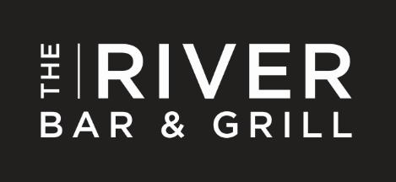

Afternoon Tea
Why not join us in The River Bar & Grill at The Lowry Hotel for our new Afternoon Tea selection for £22.50 per person for our Traditional Afternoon Tea and £33.00 for our Champagne Afternoon Tea.
Our Afternoon Tea includes:
Selection of jing loose teas, choose from:
Earl Grey
Morning blend (three blends of Assam)
Afternoon blend (50% Assam and 50% Darjeeling)
Organic Jade sword, green tea
Organic whole Chamomile flowers
Blackcurrant and hibiscus fruit infusion
Whole peppermint leaf infusion
Selection of finger sandwiches typically include:

Ham and apricot chutney
Cucumber and mint cream cheese
Cheddar and pickle
Chicken and mango creme fraiche

Selection of cakes and pastries typically include:
Strawberry and butter cream cake
Strawberry mousse pavlova
Strawberry and chocolate tartlet
Champagne jelly
Plain and fruit scones
Champagne Afternoon Tea includes all of the above, plus a home smoked mackerel pate and strawberries with whipped cream and peppered syrup.
Afternoon Tea: £22.50 per person
Champagne Afternoon Tea: £33.00 per person
Served: Monday - Friday 2.15pm till 4pm
Saturday 12pm till 4pm
Sundays 3.15pm till 5pm
Please note that this is a sample menu and is subject to change

