Express Lunch
Sample Menu

Starters
£3.00

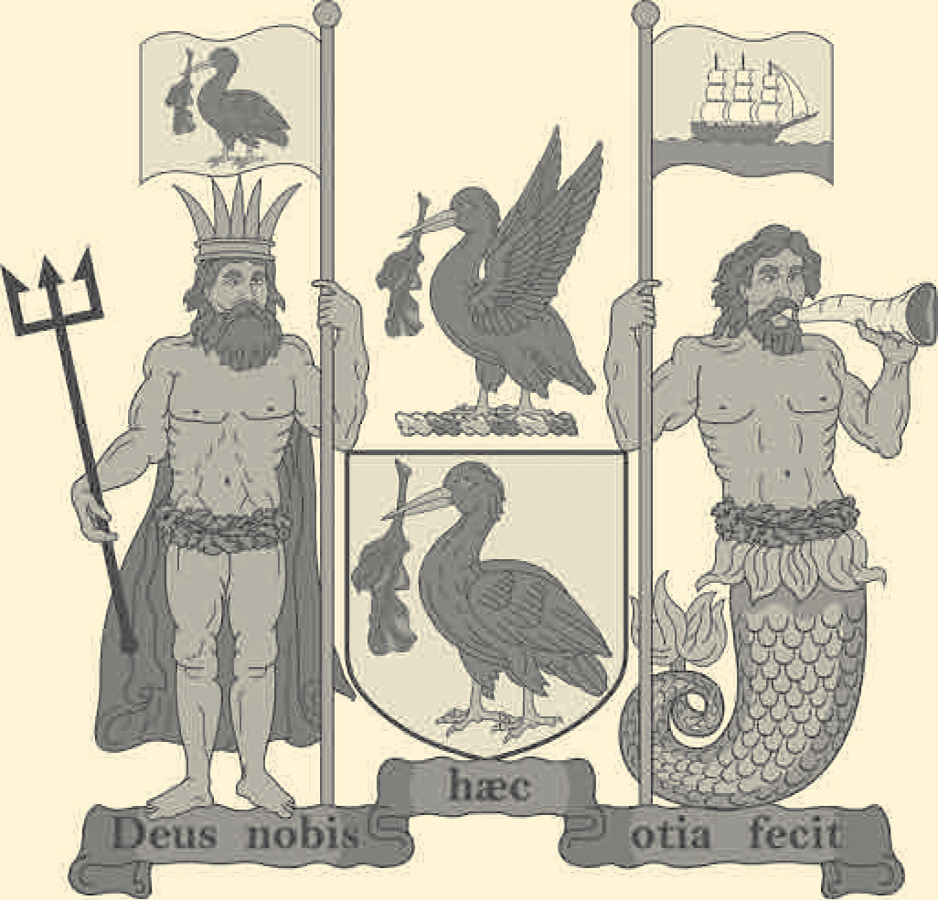
Roast Carrot & Garlic Soup, Croutons

Pan Fried Fillet of Mackerel, Sauce Vierge

Salad of Feta Cheese, Olives, Pistachio & Watercress

Main Courses
£7.00

Shepherd’s Pie, Mange Tout Peas

Braised Ox Cheek, Thyme Mash, Bourguignon Sauce

Pan of Scouse, Braised Red Cabbage, Home Baked Bread

Beer Battered Haddock, Real Chips, Mushy Peas, Tartare Sauce

Grilled Fillet of Salmon, White Onion Velouté, Pak Choi

Seared Halloumi, Butterbean & Vegetable Ragout

Puddings
£3.00

Tangerine Cheesecake

Plum & Almond Tart, Fresh Cream

Brie, Celery, Grapes & Biscuits

